

## A

**Report on**

“Name of Project Topic”

Submitted To

Shivaji University, Kolhapur

## In Partial Fulfillment of the

## Requirement

## For the Degree Of

## Final Year of B.Tech

## (COMPUTER SCIENCE AND ENGINEERING)

Submitted by

## PRN Name of Student PRN 1 Member 1

PRN 2 Member 2

## PRN 3 Member 3

PRN 4 Member 4

Under the guidance of

**Guide Name**

Submited at

**Kolhapur Institute of Technology’s College of Engineering (Autonomous), Kolhapur**

Year 2022-23



# CERTIFICATE

This is to certify that **Name of each project member along with PRN in brackets** have completed the Project Part-I on subject entitled **“Name of Project Topic”**, in the fulfilment of the requirement for the award of Final Year (Computer Science and Engineering) of KIT’s College of Engineering, Kolhapur in the academic year 2022-23.

**Date:**

**Place:** Kolhapur

Project Guide Name External Examiner Dr. A.S. Patil **Project Guide** **Head CSE**

Dr. M. B. Vanarotti **Director**

# ACKNOWLEDGMENT

We would like to express our deep gratitude towards Guide Name and Dr. A. S. Patil Head of Department for their constant en- couragement and guidance. Their support and cooperation throughout the project work has been of immerse help to us.

We express our sincere thanks to all the teaching and non-teaching staff and all those who have directly or indirectly helped in making project a success.

### PRN No Name of Student

### PRN Member 1

PRN Member 2

### PRN Member 3

PRNMember 4

# Contents

1. ABSTRACT 5
2. INTRODUCTION 6
3. REVIEW OF LITERATURE 7
4. SYSTEM ANALYSIS 8
   1. Existing System 8
   2. Requirements 9
      1. Functional Requirements 9
      2. Non-Functional Requirements 11
      3. Usability Requirements 11
      4. Implementation Requirements 11
   3. Problem Definition 12
   4. Analysis Diagrams 13
      1. Flow chart 13
      2. Entity-Relationship diagram 14
5. PROPOSED SYSTEM 15
   1. Purpose 16
   2. Scope 16
   3. System Design 17
   4. Modules Involved 17
6. REQUIREMENTS 19
   1. Hardware and Software Interface 19
7. IMPLEMENTATION 20
   1. Module Implementation 20
      1. Creation of an environment for pyretic programming . 20
      2. Implementing static firewall 20
      3. Implementing dynamic firewall 21
      4. Implementing network monitor 21
   2. Product Functions 23
   3. Screenshots 24
   4. Constraints 29
   5. Assumptions and Dependencies 29
   6. External Interface Requirements 29
   7. Implementation Architecture 30
8. PROJECT MANAGEMENT 31
   1. Process model 31
   2. Project Timeline 33
   3. Feasibility Study 34
9. TESTING 36
   1. Module Name: Dynamic Firewall 36
   2. Module Name: Network Monitor Website 40
10. CONCLUSION 42
11. REFERENCES 43

# 1 ABSTRACT

Software-Defined Networking (SDN) ensures the innovation in the net- work management by giving programmable controller a direct control over the underlying switches through an open standard Application Program- ming Interface (API), like OpenFlow. The goal of SDN is to allow Network Engineers to respond to changing business requirements, a network admin- istrator can shape traffic from a centralized control console without having to touch individual switches, and can deliver services to wherever they are needed in the network, without regard to what specific devices a server or other hardware components are connected to. The key Technologies for SDN implementation are function separation, network virtualization and automa- tion through programmability. As managing the network and providing the security is the most challenging job now-a-days, there are many threats and issues in today’s network which can be detected and removed with the help of SDN. Our project is focused solely on separation of the control plane of the network from the Data plane of the network which makes decisions about how packets should flow in the network. Controllers and devices com- municate through a controller’s southbound interface, usually OpenFlow. Hence we chose to design network security applications with SDN like Net- work Monitor, firewall at three levels i.e. L2, L3 and L4 using SDN and to implement a programmable controller which directly controls data plane of switches through API, like OpenFlow using pyretic language.

# 2 INTRODUCTION

Managing today’s computer networks is a complex and error-prone task. These networks consist of a wide variety of devices, from routers and switches to firewalls, network-address translators, load balancers, and intrusion-detection systems. Routers and switches run complex, distributed control software that is typically closed and proprietary.Software Defined Networking (SDN) is changing the way we design and manage networks. First, SDN separates the control plane (which decides how to handle the traffic) from the data plane (which forwards traffic according to decisions that the control plane makes). In SDN, a controller application uses a standard, open interface, such as Open-Flow , that can be supported by many commercial switches.Pyretic is both a response to the shortcomings of OpenFlow as a programmer API, and a client of OpenFlow in its role as an API to network switches. Programmers have used these platforms to create many applications, such as dynamic access control , server load balancing, network virtualization and their own new controller applications on top of a controller platform.So, SDN is creating exciting new opportunities for network-savvy software developers and software-savvy network practitioners alike.

# 3 REVIEW OF LITERATURE

By referring paper [1],we understood about an idea of control plane,data plane i.e. working of software defined networking through an open flow pro- tocol and many visions of SDN like programmable network, active network- ing, openFlow protocol etc.

By referring paper[2], we understood about firewalls based upon con- cept of SDN, the advantages over traditional firewalls. Firewalls based on SDN are more advanced in handling of packets dynamically and having prominent role in modern day security.

By referring paper[3], we understood about pyretic language which lowers the barrier of creating sophisticated SDN applications and allow pro- grammers to develop their own controller applications on the top of a con- troller platform and about pyretic language runtime, network policies and features.

By referring paper [4], we got familiar with various frenetic policies which we have used for firewall implementation and network monitor con- troller programming. Also algorithm for round robin load balancer is given in this paper, so that balancer can be developed based on dynamic network traffic flow.

From web reference [5], we completed our installation and platform development part as well as further actual module implementation part.

Web reference [6] is an official website for learning and implementing mininet which has commands for creating a network, customizing it as per our requirement and many more. So referring this website we implemented everything related to the network.

# 4 SYSTEM ANALYSIS

## Existing System

* + 1. Ethane Ethane project created a logically centralized, flow-level so- lution for access control in enterprise networks. Ethane reduces the switches to flow tables that are populated by the controller based on high-level se- curity policies. The simple switch design in Ethane became the basis of the original OpenFlow API.
    2. FortNOX FortNOX, a software extension that provides role-based authorization and security constraint enforcement for the NOX OpenFlow controller. FortNOX enables NOX to check flow rule contradictions in real time, and implements a novel analysis algorithm that is robust even in cases where an adversarial OF application attempts to strategically insert flow rules that would otherwise circumvent flow rules imposed by OF security applications.
    3. SDX: Software Defined Internet Exchange SDN exchange point (SDX), aims to enable more expressive policies than conventional hop-by- hop, destination-based forwarding. SDX controller that provides each ISP the abstraction of its own virtual switch and sequentially composes the poli- cies of different ISPs into a single set of rules in the physical switches. It comprises a set of participant applications running on a runtime system built on top of Pyretic. This flexibility enables applications such as inbound traffic engineering, redirection of traffic to middle boxes, wide-area server load balancing, and blocking of unwanted traffic.

## Requirements

The functional and non-functional requirements are as follows

### Functional Requirements

1. Firewall Login
2. Validity checks

Network administrator will have a unique login Id to start a controller.

* + The Login Id cannot be blank.
  + The Login Id will not accept blank spaces.
  + The Password cannot be blank.
  + The Password will not accept blank spaces

1. Sequencing information None
2. Error Handling/Response to Abnormal Situations: If the flow of any of the validations does not hold true, an appropriate error message will be prompted to the user for doing the needful.
3. Network monitor Login
4. Validity checks Admin and user login:
   * The Username cannot be blank
   * The Username will not accept blank spaces
   * The Password cannot be blank
   * The Password will not accept blank spaces
   * Username and password entered will be verified with record of database
5. Sequencing information None
6. Error Handling/Response to Abnormal Situations: If the flow of any of the validations does not hold true, an appropriate error message will be prompted to the user for doing the needful.
7. Dynamic Firewall User Inputs
8. Validity Checks:
   * Every host will have a unique IP address.
   * Every host will have a unique MAC address.
   * The length of the IP address can only be 32 bit (4 byte).
   * The length of the MAC address can only be 48 bit (6 byte).
   * IP address must be in dotted decimal format where each byte is sep- arated by dot.
   * MAC address must be in hexadecimal format where each byte is sep- arated by colon.
9. Constraints:

Each chunk of IP address should be in range between 0 and 255. Each chunk of MAC address should be in range between 00 and FF.

1. Error Handling/Response to Abnormal Situations:

If the flow of any of the validations/sequencing does not hold true, an appropriate error message will be prompted to the user for doing the needful.

### Non-Functional Requirements

* + - * Response Time: The Application responses as fast as possible.
      * Capacity: The Application will support any customized topologies with any number of hosts.
      * Design Constraint: To form the network it is necessary to have open virtual switch. This capability is provided by mininet emulator.
      * Security: It is necessary to have a secure channel between controller and the network. This channel is encrypted with SSL protocol.
      * Maintainability: The application will be designed in a maintainable manner. Application code is well documented and easy to understand.

### Usability Requirements

The system is designed for a user friendly environment so that indi- vidual and new user can perform the various tasks easily and in an effective way.

### Implementation Requirements

* + - * Vmware is a software that enables users to set up virtual machines on single physical machine and use them simultaneously along with the actual machine .
      * Ubuntu server 14.4 image includes packages like wireshark, mininet

,python 2.7.4,pyretic runtime and controller platform.

* + - * Mininet is a network emulator which creates a network of virtual hosts, switches, controllers, and links. Mininet hosts runs on standard Linux

network software, and their switches supports openFlow for highly flexible custom routing and software defined networking.

* + - * Pyretic language and runtime: Pyretic is combination of python and frenetic. Pyretic program acts as controller and output of this program is openFlow rules that are inserted in openVswitch.
      * PHP 5.5.x: It is used to develop a Network monitor website. We have deployed Network monitor through a free online hosting portal called SmarterASP.NET. Database for the website is accessed through phpmyadmin page of smarterASP.NET.
      * FileZilla: It is a tool for accessing the files on ftp. We use filezilla to upload and download files from hosting.

## Problem Definition

To provide the network security applications in the form of a static and dynamic firewall at layer 2(i.e.Data link layer) and layer 3(i.e.Network layer), a port level firewall and a managable network monitor with a website interface.

## Analysis Diagrams

### Flow chart

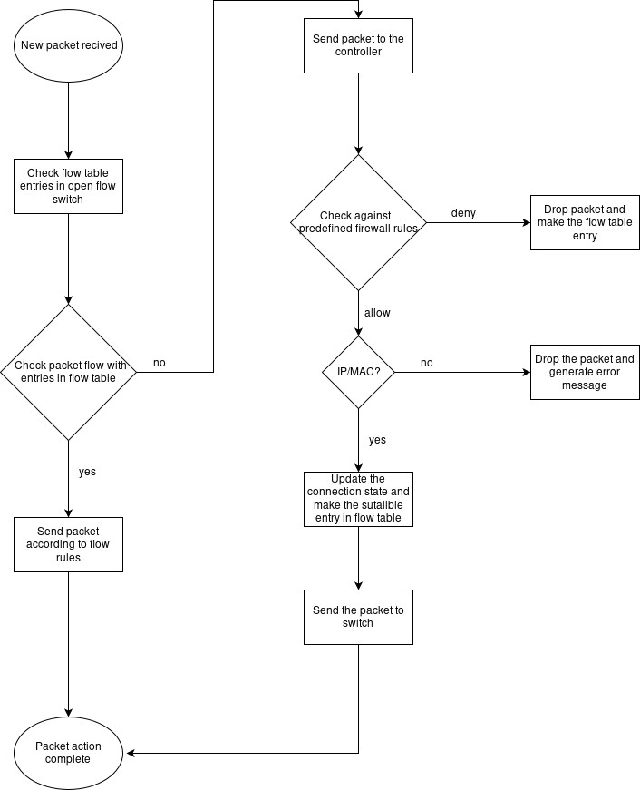

Fig 4.1 Flow Chart of dyanamic firewall

### Entity-Relationship diagram

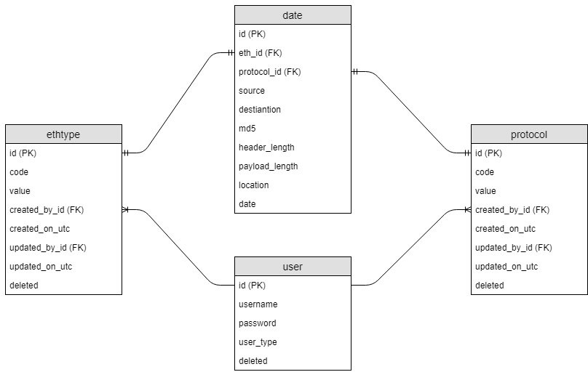

Fig 4.2 E-R diagram of database

# 5 PROPOSED SYSTEM

Software-Defined Networking (SDN) is an emerging architecture that is dynamic, manageable, cost-effective, and adaptable, making it ideal for the high-bandwidth, dynamic nature of today’s applications. This architec- ture decouples the network control and forwarding functions enabling the network control to become directly programmable and the underlying in- frastructure to be abstracted for applications and network services. The separate SDN controller makes high level routing decisions where the com- munication between devices and controller is performed by an OpenFlow interface. Controllers and switches communicate via a controller’s “South- bound” interface, usually OpenFlow.

The proposed solution consists of the static and dynamic firewall at Layer2 and Layer 3 managable via an android application and a network monitor interface.

* + - * The static firewall does handling, forwarding, dropping and monitoring of packets according to the predefined policies in the controller.
      * The dynamic firewall provides an interface to forward, drop and moni- tor the packets, to manage the packet flow in the network dynamically at any given time.
      * Network monitoring system monitors the network for problems caused by overloaded or crashed servers, network connections or other devices.
      * Network monitoring system gives an information regarding each and every packet flowing through the network e.g. source and destination IP, Mac address of hosts, header and payload length, etc.
      * A fully configurable and centrally managed firewall (L2, L3). Mak- ing static and dynamic firewall managed by an android application interface to allow and block a particular host using its IP address.
      * A port level firewall(L4 level) that will allow and block a specifed port in our network.

L2 security provides filtering through the MAC addresses at Data Link Layer, L3 security is provided filtering through IP addresses at Network and L4 security provides filtering through ports on Network

## Purpose

The problem with data center is that they are having hundreds of nodes to reconfigure, in this case, n/w administrator needs to configure multiple devices (switches, routers) on a device-by-device basis manually which is a tedious task. This is due to decentralized control plane, so sepa- rate configuration is required for each device’s control plane to manage its respective data plane.

The currently configuring of the network is done using proxy server.A dedicated server is required to manage the network and its functioning. Also proxy server operates at application layer. Our proposed system will operate on network layer. The configuration is done at switch itself, it will eliminate the need for extra hardware like proxy server and other network devices as- sociated with it. Proxy server can be a point of bottleneck to the network. Traditional network consists of proprietary devices or nodes. these de-

vices have proprietary firmware which cannot be changed. One can’t flash his own program in existing devices (e.g. switches like Dlink, Cisco) as we don’t know the language of it’s control plane.

## Scope

The goal of SDN is to allow network engineers and administrators to respond quickly to changing business requirements. In software defined

network administrator can shape traffic from a centralized control console without having to touch individual switches, and can deliver services to wherever they are needed in network, without regard to what specific devices a server or other devices connected to.

## System Design

System Design’s main aim is to identify the modules that should be in the system, the specifications of these modules and how they interact with each other to produce the desired results. At the end of system design, all the major data structures, file formats and the major modules in the system and their specifications are decided.

## Modules Involved

* + - Static firewall: The following module will implement a firewall which will manage the flow of packets proactively.
    - Dynamic firewall: The implemented firewall rules are not permanent. So ,as and when required,firewall rules are modified by the security administrator. However, this is carried out manually by changing the controller each time,which is not effective. In continuation of the is- sue discussed above about attack-based-prevention,it is required to have a system which automatically formulate new firewall rules as an outcome of attack analysis. So we are aiming at building a dynamic firewall,which will block such attackers(intruders)which may be infil- trating the network.
      * L2 level firewall all: L2 security provides filtering through the MAC addresses at Data Link Layer.
      * L3 level firewall: L3 security is provided filtering through IP ad- dresses at network from a managable android apllication interface
      * L4 level firewall: L4 level security is provided by filtering through ports available on the network.
    - Network Monitor: This system will perform an analysis and reporting of packet flow between different hosts in a network and will display the packet flow on a website platform where admin user can edit and delete specific ethtypes or protocol privileges.

# 6 REQUIREMENTS

## Hardware and Software Interface

Hardware Requirements:

* + - Processor : core i3 and above
    - RAM : 4GB and above
    - Disk Space : 20 GB Software Requirements:
    - VMware or Virtualbox
    - Mininet network emulator
    - Pyretic runtime
    - SSH or Putty
    - Xming or Xterm
    - Wireshark

# 7 IMPLEMENTATION

## Module Implementation

### Creation of an environment for pyretic programming

This module implementation consists of the installation of VMware Workstation on windows platform and importing ubuntu server 14.4 image which has installed packages like mininet network emulator and pyretic run- time. Installation of Xming application for X11 display and puTTY.

### Implementing static firewall

1. Learning frenetic policies:
   * Identity - Returns original packet
   * match(f=v) - Identity if field f matches v, none otherwise
   * fwd(a) - Returns copy of packet having outport field is set to ‘a’
   * flood()- Returns one packet for each local port on the network spanning tree.
   * drop - Drops the packet
   * Composition operators

i].Parallel composition ii]Sequential composition.

1. Firewall implementation:

The firewall does handling, forwarding, dropping and monitoring of packets according to the policies defined in the controller.

### Implementing dynamic firewall

In dynamic firewall using object oriented concepts, threading and fre- netic policies,network controller is designed which dynamically manipulates the policies of flow table of router depending on the administrator’s in- put. Manipulation of network consist of allow MAC/IP/PORT and Block MAC/IP/PORT.

### Implementing network monitor

Network monitor module implementation is done to report an ongoing packet flow in the current network to web application using a web api like php.

1. Network monitor controller using pyretic Frenetic policies are used. i.e.Query policies which analyzes or filters the flow of packet

|  |  |
| --- | --- |
| Syntax | Summary |
| packets( limit=n, group-by=[f1,f2,...]) | callback on every packet received for up to n packets identical on  fields f1,f2,... |
| count-packets( interval=t, group-by=[f1,f2,...]) | count every packet re- ceived callback every t seconds providing count  for each group |
| count-bytes( interval=t, group-by=[f1,f2,...]) | count every byte re- ceived callback every t seconds providing count for each group |

1. Network Analyzer web application:

This show traffic flowing through the network on the website to the administrator as well as the user. This module also has the feature to ma- nipulate ethtype and protocols. The module is implemented using server- side scripting language PHP to develop a web application.The database is created for storing network traffic information, protocol and ethtype infor- mation and user information for authentication purpose. The database, all php files are placed on a server so that website is available and accessible all the time.

## Product Functions

Dynamic Firewall:

1. Allow IP and MAC and port:

This module adds IP address to the list of IP addresses. The IPs which are in the list should be allowed to send packets in the network. Sim- ilarly their is one list for MAC addresses. MACs entered in this list will be allowed to send packets in the network. It is necessary to pass that IP address or MAC address that need to be allowed to frenetic policies in the form of tuple.In allow PORT module, user enters PORT number to allow already blocked PORT.

1. Block IP and MAC and PORT:

This module blocks a host by dropping all the packets whose either source or destination is the entered IP address or MAC address. Block IP deletes the entered IP address from the list of IP addresses. Same is the case with block MAC, it blocks the MAC address entered by deleting the MAC address entry from the list..In block PORT module, user enters PORT number to block that PORT.

Network Monitor

A] Add eth type/Add protocol:

This allows network administrator to add new eth type or protocol.

For each ethtype/protocol administrator has to provide code-value pair. B] Edit ethtype/ Edit protocol:

This allows administrator to edit eth type or protocol.

C] Delete ethtype/protocol:

This allows administrator to delete selected eth type or protocol.

## Screenshots

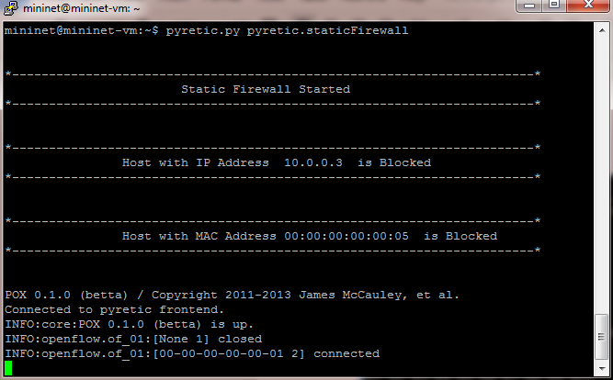

Fig 7.3.1 Static Firewall Controller

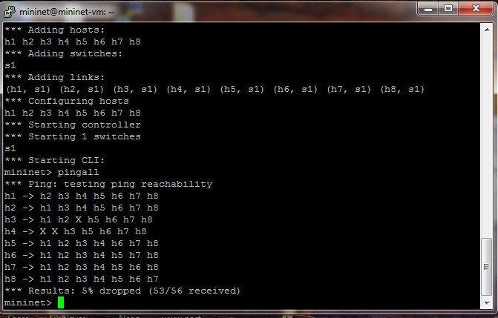

Fig 7.3.2 Dynamic Firewall Execution details

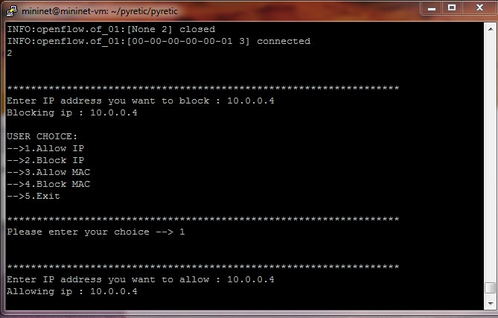

Fig 7.3.3 Dynamic Firewall Execution

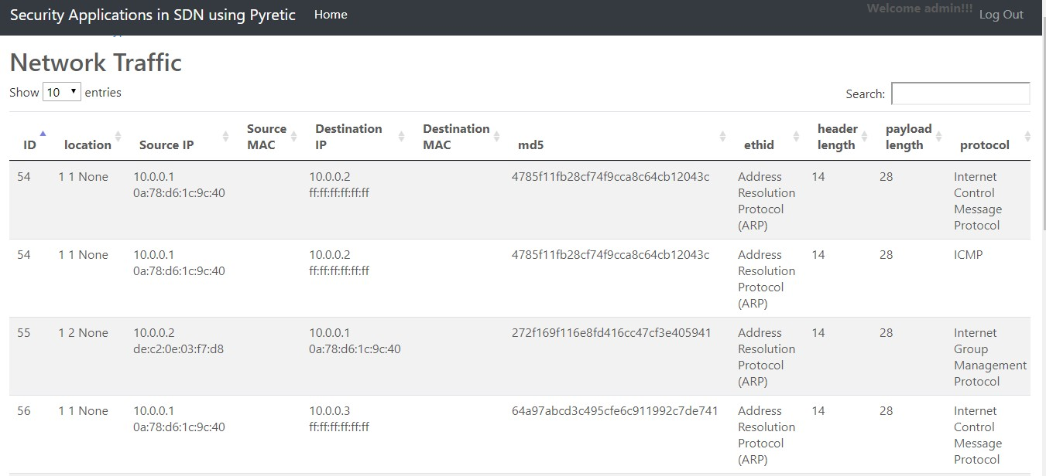

Fig 7.3.4 Network packet flow

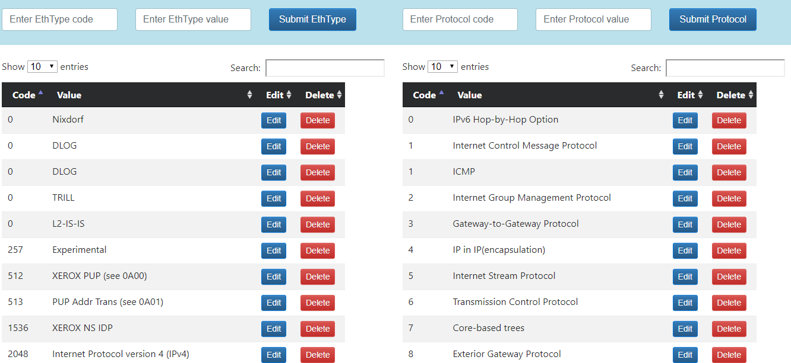

Fig 7.3.5 Network Monitor Website

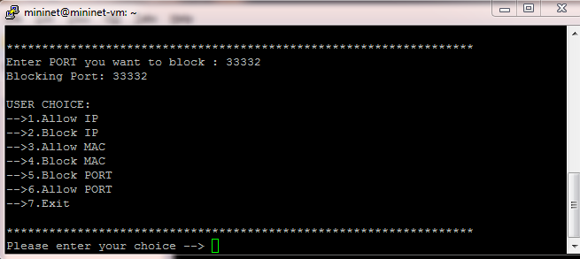

Fig 7.3.6 Blocking the port number using dynamic firewall

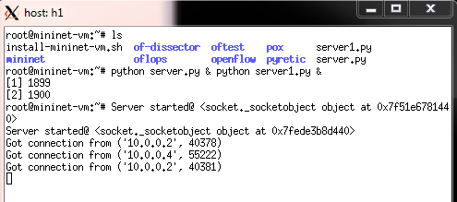

Fig 7.3.7 Server h1

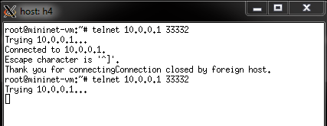

Fig 7.3.8 Client h4 not able to connect to blocked port 33332

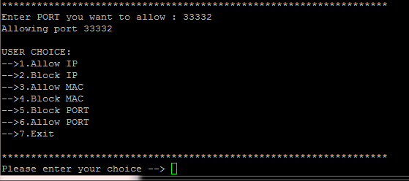

Fig 7.3.9 Allowed port 33332

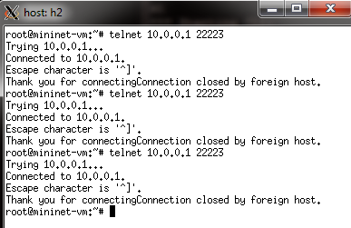

Fig 7.3.10 Client h2 is connected to 22223

## Constraints

It is necessary to start controller before the network is initialized.

## Assumptions and Dependencies

The login Id and password must be known to authorized user to protect confidentiality.

## External Interface Requirements

Putty an external SSH client is used to get windows command line interface for interaction with the guest OS running on virtual machine.

User Interfaces

An android application interface to provide an access to manage dy-

namic firewall and a web interface to manage ongoing packet flow is provided to the user.

## Implementation Architecture

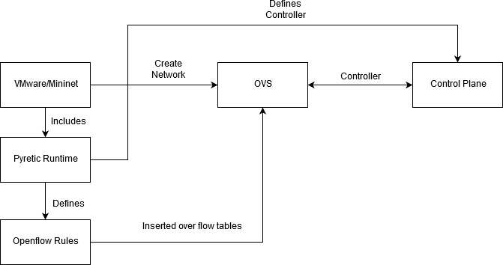

Fig 7.6.1 Implementation Architecture

# 8 PROJECT MANAGEMENT

## Process model

In the Iterative model, iterative process starts with a simple implemen- tation of a small set of the software requirements and iteratively enhances the evolving versions until the complete system is implemented and ready to be deployed.

Iterative process starts with a simple implementation of a subset of the software requirements and iteratively enhances the evolving versions un- til the full system is implemented. At each iteration, design modifications are made and new functional capabilities are added. The basic idea behind this method is to develop a system through repeated cycles (iterative) and in smaller portions at a time (incremental). he key to a successful use of an iterative software development lifecycle is rigorous validation of require- ments, and verification and testing of each version of the software against those requirements within each cycle of the model.As the software evolves through successive cycles, tests must be repeated and extended to verify each version of the software.

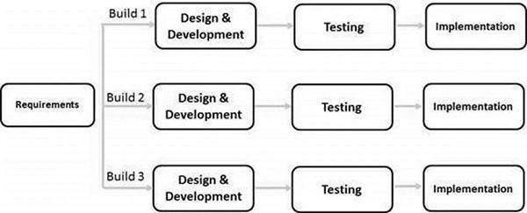

Fig 8.1.1 Iterative model

## Project Timeline

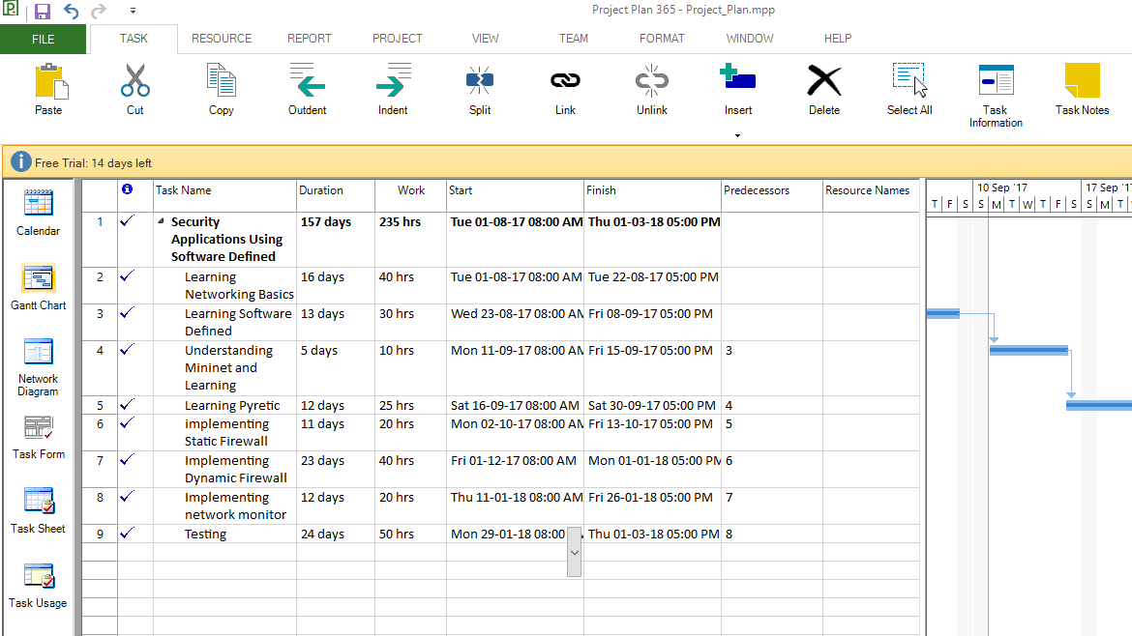

Fig 8.2.1 Project Plan Chart

## Feasibility Study

1. Introduction

While the need for software-defined networking (SDN) technologies will be driven by specific network requirements, the most common chal- lenge driving SDN within the data center is that large data center networks do not easily support the dynamic requirements of server virtualization. Specifically, this means the ability to provision network services quickly and easily to new virtual machines. Outside the data center, however, SDN could change WANs, campus networks and branch networks that need to have open APIs and improved network flexibility to support dynamic traffic flows to reduce latency and guarantee Quality of Service for specific appli- cations.

1. Technical feasibility

It is possible to implement Software Defined Network virtually. Pyretic provides a ubuntu server image that contains packages like mininet, python, pyretics runtime,etc. Pyretic is one member of the Frenetic family of SDN programming languages. As such Pyretic enables network programmers and operators to write succinct modular network applications by providing pow- erful abstractions. Pyretic is both a programmer-friendly domain-specific language embedded in Python and the runtime system that implements programs written in the Pyretic language on network switches. The equip- ments and the software to satisfy the user requirements:

1. VMware: Virtual machine (VM) is an emulation of a computer system. Virtual machines are based on computer architectures and provide function- ality of a physical computer. Their implementations may involve specialized hardware, software, or a combination.
2. The Pyretic platform, language and runtime system.
3. PuTTY
4. Xming
5. Economic Feasibility

Special SDN switches are not required to implement software-defined networks. SDN architectures will take many different approaches as they mature and change, and each technology vendor will have a unique take on how to implement SDN. For example, VMware, with its acquisition of Nicira, will implement SDN protocols in its vSwitch software, which does not require specialized hardware or a controller.

1. Operational Feasibility

Pyertic has policies that describes what the network switches should do with incoming packets. Pyretic policy is a function that takes a packet as input and returns a set of packets. For example a function that takes any packet and returns the empty set when applied as the overall network policy will cause the network to drop all packets. Likewise a function that takes any packet arriving at a given location (switch and port) and returns the set of packets which are identical to the original but located respectively at the ports at that switch which lie on the network spanning tree, applied as the overall network policy will cause the network to flood all packets. However, Pyretic policies can be built from other policies using composition such as parallel and sequential composition, so policies such as the ones above can be building blocks of the overall network policy, as opposed to only being used as the overall network policy itself. The MAC learner module provides an example of just such a policy. As Pyretic is embedded in Python, we’ve chosen to implement these conceptual policy functions as instances of classes that descend from the Policy class defined in language.py.

# 9 TESTING

## Module Name: Dynamic Firewall

Test Title: Block IP

Test summary/Description:

|  |  |  |  |  |
| --- | --- | --- | --- | --- |
| Test Condition | Test Data | Expected result | Actual Result | Status of  Test Case |
| Enter invalid IP | abcd | Invalid IP Enter  valid IP: | Invalid IP Enter  valid IP: | Passed |
| Before blocking IP | pingall | Should allow all hosts to ping each  other | Allows all hosts to ping each other | Passed |
| After blocking certain IP | pingall | Should allow all hosts to ping each other except for  one’s blocked | Allows all hosts to ping each other except for one’s  blocked | Passed |

Test Title: Allow IP

Test summary/Description:

|  |  |  |  |  |
| --- | --- | --- | --- | --- |
| Test Condition | Test Data | Expected result | Actual Result | Status of  Test Case |
| Enter invalid IP | abcd | Invalid IP Enter  valid IP: | Invalid IP Enter  valid IP: | Passed |
| Initially no host is blocked,now al-  lowing a host | pingall | All MAC’s are al- ready allowed | All MAC’s are al- ready allowed | Passed |
| Before allowing IP | pingall | Should block full traffic to hosts  that are blocked | Blocks full traffic to hosts that are  blocked | Passed |
| After allowing certain IP | pingall | Should allow all hosts to ping each other except for one’s which are  still blocked | Allows all hosts to ping each other except for one’s which are still  blocked | Passed |

Test Title: Block MAC Test summary/Description:

|  |  |  |  |  |
| --- | --- | --- | --- | --- |
| Test Condition | Test Data | Expected result | Actual Result | Status of  Test Case |
| Enter invalid  MAC | abcd:8h | Invalid MAC En-  ter valid MAC: | Invalid MAC En-  ter valid MAC: | Passed |
| Before blocking MAC | pingall | Should allow all hosts to ping each  other | Allows all hosts to ping each other | Passed |
| After blocking certain MAC | pingall | Should allow all hosts to ping each other except for  one’s blocked | Allows all hosts to ping each other except for one’s  blocked | Passed |

Test Title:Allow MAC

Test summary/Description:

|  |  |  |  |  |
| --- | --- | --- | --- | --- |
| Test Condition | Test Data | Expected result | Actual Result | Status of  Test Case |
| Enter invalid  MAC | abcd:8h | Invalid MAC En-  ter valid MAC: | Invalid MAC En-  ter valid MAC: | Passed |
| Initially no host is blocked,now al-  lowing a host | Pingall | All MAC’s are al- ready allowed | All MAC’s are al- ready allowed | Passed |
| Before allowing MAC | pingall | Should block full traffic to hosts  that are blocked | Blocks full traffic to hosts that are  blocked | Passed |
| After allowing certain MAC | pingall | Should allow all hosts to ping each other except for one’s which are  still blocked | Allows all hosts to ping each other except for one’s which are still  blocked | Passed |

## Module Name: Network Monitor Website

Test Title: Login page

Test summary/Description:

|  |  |  |  |  |
| --- | --- | --- | --- | --- |
| Test Condition | Test Data | Expected result | Actual Result | Status of  Test Case |
| Only username entered | Username:adm  pass- word:empty | in  Fill all the fields | Fill all the fields | Fill all the fields |
| Only Password entered | Username: empty password:  admin | Fill all the fields | Fill all the fields | Fill all the fields |
| Both username and password entered | Username: admin password:  admin | Directed to the home page | Directed to the home page | Fill all the fields |

Test Title: Network Traffic Test summary/Description:

|  |  |  |  |  |
| --- | --- | --- | --- | --- |
| Test Condition | Test Data | Expected result | Actual Result | Status of  Test Case |
| Date and Time | Ping h1 to  h2 | Current date and  time | Current date and  time | Passed |
| Packet | Packet  String from controller | Same as that of  controller output on website | Same as that of  controller output on website | Passed |

Test Title: Edit/Delete/Search Ethtype and Protocol Test summary/Description:

|  |  |  |  |  |
| --- | --- | --- | --- | --- |
| Test Condition | Test Data | Expected result | Actual Result | Status of  Test Case |
| Submit /Insert EthType | EthType code and ethtype | Code and Value are given | Code and Value are given | Code and  Value is given |

# CONCLUSION

SDN firewalls have become a prominent role in modern day security. Due to the openness of SDN system, it provides flexibility by programming centralized controller, which helps in handling the whole network locally as well as remotely. Openflow protocol is a southbound interface which be- haves as an event handler that responds to events such as packet arrivals, topology changes and new traffic statistics. Pyretic language is a combina- tion of python and frenetic languages which acts as a northbound interface that lowers the barrier to create sophisticated SDN applications like static, dynamic firewall and network monitor.

Logically centralized n/w OS i.e. controller gets a global view of an entire network.Network Firewall is this controller that allows us to manage the network. A fully configurable and manageable firewall is developed at Layer 2 (i.e.filtering through the MAC addresses at Data Link Layer) and Layer 3(i.e. filtering through IP addresses at Network Layer ) as well as Layer 4(i.e. filtering through port numbers at Transport Layer)

Another application is network monitor which monitors the network for problems caused by overloading of congestion or crashed servers, network connections or other devices. It enables capturing,viewing, and analyzing network data and deciphering network protocols.

# REFERENCES

* + 1. The Road to SDN: An Intellectual History of Programmable Networks by Nick Feamster-Georgia Tech, Jennifer Rexford-Princeton Univer- sity ,Ellen Zegura-Georgia Tech .
    2. Software defined network : comprehensive survey by Diego Kreutz, Member IEEE, Fernando M. V. Ramos, Member IEEE, Paulo Es- teves Veri Ssimo, Fellow IEEE, Christian Esteve Rothenberg, Member IEEE,Siamak Azodolmolky, Senior Member IEEE, and Steve Uhlig, Member IEEE
    3. Implementation of Stateful SDN Firewall : Madusha Jayawardhana, Ninada Perera, Priyankara Bandara, Dr. Suneth Namal, Mr. Sam- path Deegalla, Department of Computer Engineering, University of Peradeniya, Sri Lanka
    4. Modular SDN Programming with Pyretic:Joshua Reich, Christopher Monsanto, Nate Foster, Jennifer Rexford, and David Walker
    5. Pyretic : https://github.com/frenetic-lang/pyretic/wiki
    6. Mininet network emulator : <http://mininet.org/sample-workflow/>